As part of embroidering in the Diaspora Tapestry project I would like to submit part of the history of my family, as it pertains to the linen industry in Dunfermline and abroad, as the diaspora spread to the USA and Australia, my home.
There are details of clothing worn and linen manufacturing that I have highlighted as they may be of interest to the project.
The Macpherson Family of Dunfermline
Edited memoir of Alec Macpherson Adair by Helen Johnson nee Macpherson

John Macpherson, linen worker, 1825- 1897
Excerpts from a memoir by his grandson Alec Macpherson Adair
“In Dunfermline the family of John Macpherson lived at 58 Appin Crescent which was a sandstone house consisting of ground floor and attic with a garden in front, an entry or close leading to the back and a large garden in the back. Flowers were grown in the front and gooseberry, currant , rhubarb and other vegetables in the back. There was also the wash house and coal house, the toilet and ashpit or midden as it was then called.
One end of the house had been what was called the loom shop and the other end was used as living quarters and had a sandstone flight of steps to the upstairs. I don’t know if Grandpa ever operated a hand loom but he employed a couple of hand-loom weavers. Grandma and my mother were kept busy winding yarn onto the pirns or bobbins and, when the linen or damask was completed, they beetled it on the front doorstep as there were no mangles in those days. I find it all very interesting to look back upon.
My Grandpa was very friendly with a man called Hay, who married a woman called Robertson, and from this union developed the great linen manufacturing firm called Hay and Robertson. Grandpa worked for them as head lapper or folder of the linen until he retired at about 70 years of age. As long as he worked for them Mr Roberson would call Grandpa into his private office and the two of them would sit in there and have a wee dram and a friendly crack (chat) together. Later on the head of the firm was his son Sir William Roberston who lived in one of the finest mansions alongside the Public Park in Dunfermliine.
Grandpa was a tall, spare man, without an ounce of fat. He was a genial preson and seldom got angry. Though not rigidly righteous he was a good man who attended church every Subday. In his latter days he was always accompanied by me. On Sunday morning Grandma brought his top hat out from its place in The Room and then he dressed in a fine black tail coat, grey trousers, polished boots and gloves and in this way he was dressed for Kirk. I would say he was a man respected by all and sundry.
Grandma was the mainstay of the family and from whom it derived its high character and ambition. She was a small person, always tidy and alert, very saving and economical, never wasted apenny. She always wore a mitch or little cap, black with little red flowers during the day and a white one to go to bed with.
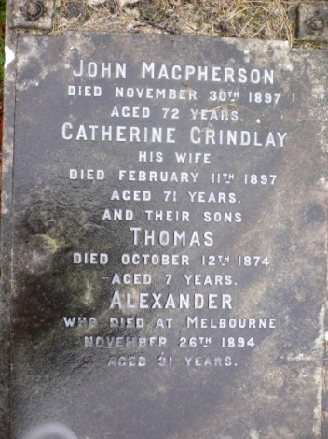
http://dunfermlineauldgreytoon.com/at-your-service-dunfermline-auld-grey-toon/mills-in-images-dunfermline-auld-grey-toon/linen-mill-machine-in-use-at-hay-robertsons-mill-in-pilmuir-street
Graham Macpherson, linen salesman, 1849-1909, eldest son of John.
He was an outstanding man in the town of Dunfermline. He was a stoutish, stockily built man with a fine growth of moustache and side whiskers.
Graham was principal salesman and executive for Hay and Robertson, possibly the largest linen manufacturer in Dunfermline. He was an officer in the local Volunteers, connected with the Black Watch, an officer in the church of St Margaret’s United Presbyterian and captain of the town cricket club. Two sons also worked for Hay and Robertson.
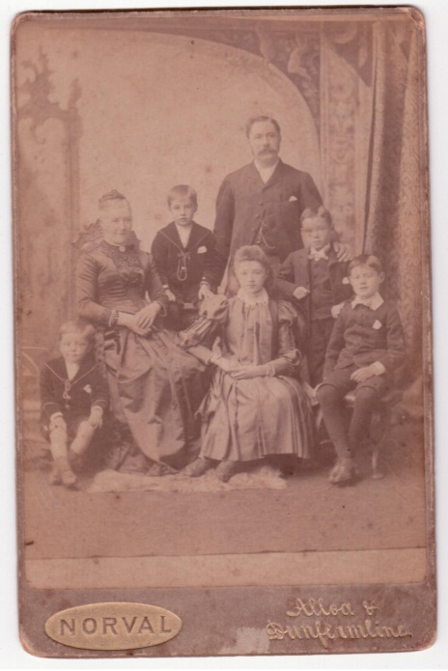
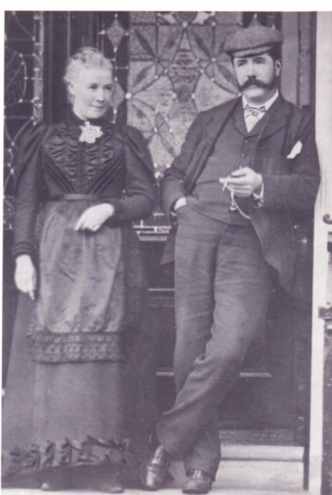
Family from top row Graham jnr, John, Robert, Nan, Tom c 1890
Graham and Margaret c 1880
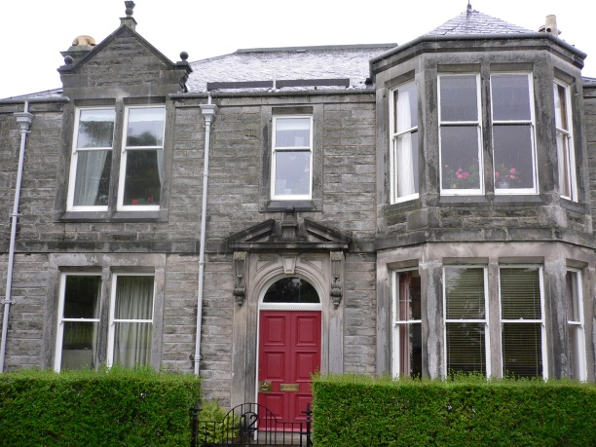
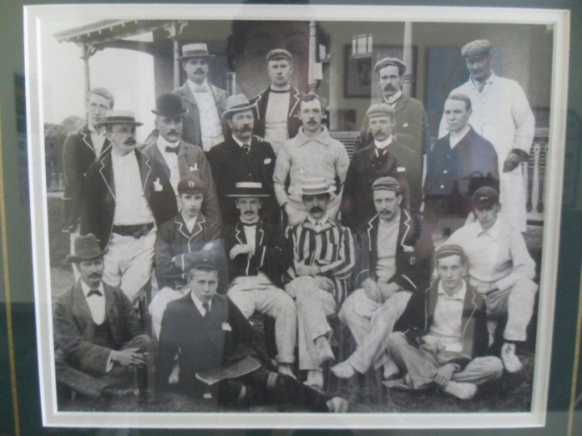Dunfermline Cricket Team c 1900
Graham's home at 12 Park Pl, Dunfermline
Photo of Graham Macpherson, 2nd row from top, 4th from right
His son, also Graham, seated 2nd row from bottom , far left.

Graham Macpherson, 1883-? Linen salesman New York, son of Graham
Graham’s son Graham became a salesman for Hay and Robertson and emigrated to the USA selling linen as their agent. He lived in Upper Mont Clair and was an outstanding cricketer. He was wonderfully smart and popular socially and much respected in the community.
Robert (Bert) Macpherson, 1885- ? Linen salesman New York, son of Graham
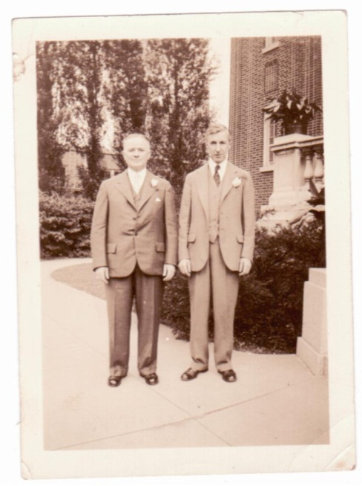
Brother Bert also emigrated to the USA and worked for Hay and Robertson. He lived in Bay Ridge Brooklyn. He was a very great singer and to hear him singing ‘My Ain Folk’ and some of the other old Scots’ songs was indeed a treat. He was also a fine cricketer.
Robert and Graham Macpherson, USA and at Robert’s wedding , 1934
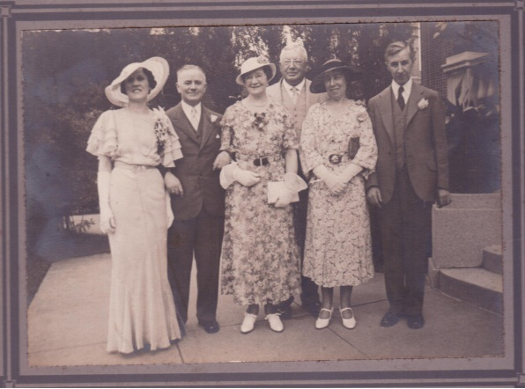

Thomas Macpherson, 1881-1953, Draper, Sydney, Australia
Thomas was apprenticed to a drapery retail shop in Dunfermline. He often stopped at his grandfather’s house and was a welcome visitor. He would spend the evening telling stories and aunts Aggie and Lizzie enjoyed him very much. He then worked as a draper in Glasgow before emigrating to Sydney, Australia with his fiance Catherine Murray in 1909.“
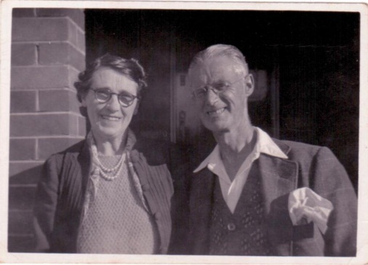
Thomas was my grandfather and worked as a draper in a department store in Sydney before being laid off for a period during the Great Depression, with resulting hardship on my father and siblings. He eventually bought a house in Ramsgate, Sydney and named it Briery House, after his father’s Dunfermline home in Park Pl.

Robert (Bert) Macpherson, 1918-2011, Asst Deputy Commissioner Taxation, Sydney.
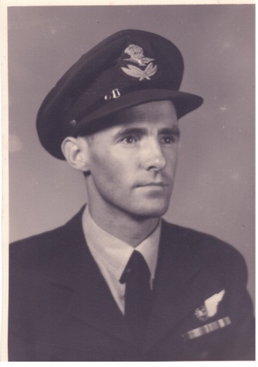
Robert was Tom’s son and my father, and was a Flight Lieutenant in the RAAF in World War Two. He spent a lot of time in his retirement from the Tax Office tracing our family tree, for which we are grateful. He has 3 children and 4 grandchildren. His grandson, Robbie, is a member of the Hills Pipe Band in Sydney, of which our Scottish ancestors would be proud. We also attend Brigadoon at Bunadoon clan gatherings and I am a member of the Clan Macpherson Association.
Flight Lieutenant Robert Macpherson
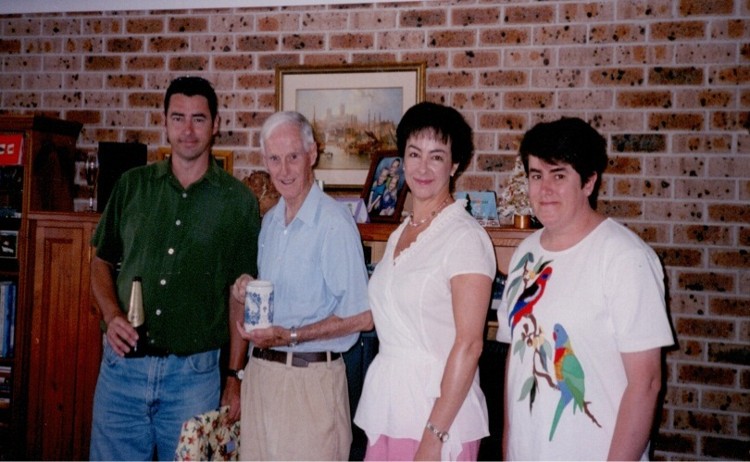

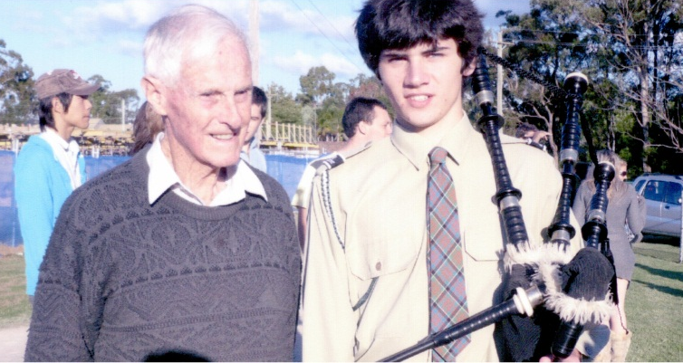
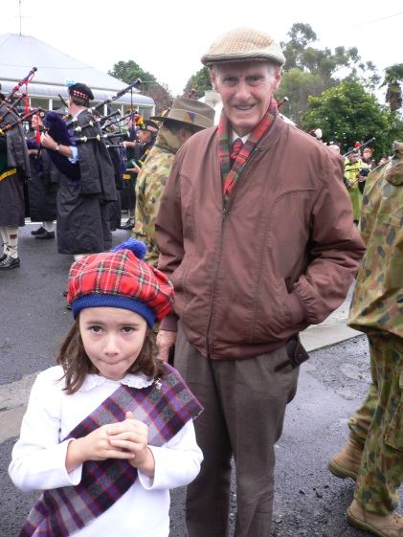
Son Murray, Robert Macpherson, daughters Helen and Linda

Grandpa with Robbie Macpherson

Grandpa with Robbie Macpherson
Fiona Macpherson with Grandpa

I am very excited at being a part of the Diaspora Tapestry project, especially to be embroidering on linen, which my great, great grandfather once created and my great grandfather, great uncles and grandfather sold in Scotland, the USA and Australia.
A diaspora.
Helen Johnson, nee Macpherson, West Pennant Hills, Sydney, 2012

